**Prepared for:**

**Centers for Medicare & Medicaid Services and Office of the National Coordinator for Health Information Technology**

**Technical Authority for the Unified Clinical Quality   
Improvement Framework**

**Bonnie User Guide**

**Version 5.1.1**

**November 22nd, 2021**

**Record of Changes**

| **Version** | **Date** | **Author / Owner** | **Description of Change** |
| --- | --- | --- | --- |
| 0.1 | April 15, 2014 | Andre Quina / MITRE | Initial draft |
| 0.1.1 | July 18, 2014 | Cristen Jones / MITRE | Update for Bonnie v 1.1 |
| 0.2 | April 13, 2015 | Cristen Jones / MITRE | Update for Bonnie v 1.3 |
| 1.4 | January 13, 2016 | Pace Ricciardelli / MITRE | Update for Bonnie v 1.4 |
| 1.5 | November 18, 2016 | David Connolly and Lizzie DeYoung / MITRE | Update for Bonnie v 1.5 |
| 1.6 | January 4, 2017 | Kristian Mulcahy and Chris Tohline / MITRE | Update for Bonnie v 1.6 |
| 1.6.5 | June 8, 2017 | Chris Tohline / MITRE | Update for Bonnie v 1.6.5 |
| 2.0 | November 14, 2017 | Rose Almonte, Lizzie Charbonneau, Chris Tohline, Jenn Reed / MITRE | Update in preparation for Bonnie v 2.0 |
| 2.1 | May 3, 2018 | Lizzie Charbonneau / MITRE | Update for Bonnie v 2.1 |
| 2.1.2 | May 31, 2018 | Lizzie Charbonneau / MITRE | Update for Bonnie v 2.1.2 |
| 2.2 | July 13, 2018 | Cole Springate-Combs / MITRE | Update for Bonnie v 2.2 |
| 2.3 | August 23, 2018 | James Bradley / MITRE | Update for Bonnie v 2.3 |
| 3.0 | October 16, 2018 | James Bradley / MITRE | Update for Bonnie v 3.0 |
| 3.1 | November 15, 2018 | James Bradley / MITRE | Update for Bonnie v 3.1 |
| 3.2 | May 21, 2019 | James Bradley / MITRE | Update for Bonnie v 3.2 |
| 4.0 | August 27, 2019 | James Bradley / MITRE | Update for Bonnie v 4.0 |
| 4.2 | October 19th, 2020 | Nicole Hunter / SemanticBits | Update for Bonnie v 4.2 |
| 4.2.1 | January 25th, 2021 | Nicole Hunter / SemanticBits | Update for Bonnie v 4.2.1 |
| 5.0.0 | July 6th, 2021 | Nicole Hunter / SemanticBits | Update for Bonnie v 5.0.0 |
| 5.1.0 | October 21st, 2021 | Nicole Hunter / SemanticBits | Update for Bonnie v 5.1.0 |
| 5.1.1 | November 22, 2021 | Nicole Hunter / SemanticBits | Update for Bonnie v 5.1.1 |

**Table of Contents**

1. **Introduction** **5**

1.1 Background 5

1.2 Purpose 5

1.3 Application Description 5

1. **Accessing Bonnie and Account Management** **7**

2.1Login Requirements 7

2.2 Creating a New User 7

2.3 Logging In 7

2.4 Logging In - First Time Existing User 9

2.4.1 Auto Linking Accounts 9

2.4.2 Manual Linking Accounts 9

2.5 Resetting a Password 9

2.6 Group Accounts 10

2.7 Account Management 10

1. **Measure Dashboard** **12**

3.1Overview 12

3.2 Loading a New Measure 13

3.2.1 Value Set Options 14

3.3 Updating an eCQM 16

3.4 Creating Synthetic Test Records 17

1. **Measure Results View** **18**

4.1Overview 18

4.2 Measure Logic 20

4.3 Creating a New Test Record 21

4.4 Calculation Results 21

4.5 Editing a Test Record 23

4.6 Cloning a Test Record 24

4.7 Deleting a Test Record 24

4.8 Updating a Measure 24

4.9 Deleting a Measure 24

4.10 Updating Measurement Period 24

4.11 FHIR Patient Export 25

1. **Building a Patient Test Record** **26**

5.1Overview 26

5.2 Building a Synthetic Patient 27

5.3 Building the Patient History 28

5.4 Incremental Calculation 30

1. **Export/Import Patient Workflow** **31**

6.1Export Patients **31**

6.2Import Patients **31**

**Feedback and Support** **34**

**Frequently Asked Questions** **35**

**List of Figures**

Figure 1. Bonnie Account Registration Page 7

Figure 2. HARP Login Page 8

Figure 3. Two Factor Authentication Example 9

Figure 4. Group Account Drop Down 10

Figure 5. Profile Page 11

Figure 6. Measure Dashboard View 12

Figure 7. New Measure Dialog 13

Figure 8. Value Set Options – Profile 15

Figure 9. Value Set Options - Release 16

Figure 10. Updating Measure Dialog 17

Figure 11. Measure View 19

Figure 12. Measure Terminology and Overlapping Value Sets 20

Figure 13. Expanded Results View 22

Figure 14. Logic Calculation Highlight – Passing Results 22

Figure 15. Logic Calculation Highlight – Expanded Result 23

Figure 16. Logic Calculation Highlight – Failing Results 23

Figure 17. Change Measurement Period 25

Figure 18. Patient Builder View 26

Figure 19. Continuous Variable Measures Expected Populations 28

Figure 20. Building Patient History, Including Edit Clinical Element View 29

Figure 21. Patient Action Row 31

Figure 22. Successful Patient Export Message 31

Figure 23. Patient Import File Selector 32

Figure 24. Successful Patient Import; Expected Values Copied 33

Figure 25. Successful Patient Import; Expected Values Dropped 33

# Introduction

## Background

Bonnie is a software tool that allows electronic clinical quality measure (eCQM) developers to test and verify the behavior of their eCQM logic. The main goal of the Bonnie application is to reduce the number of defects in eCQMs by providing a robust and automated testing framework. The Bonnie application allows measure developers to independently load measures that they have constructed using the Measure Authoring Tool (MAT). Developers can then use the measure metadata to build a synthetic patient test deck for the measure from the clinical elements defined during the measure construction process. By using measure metadata as a basis for building synthetic patients, developers can quickly and efficiently create a test deck for a measure. The Bonnie application helps measure developers execute the measure logic against the constructed patient test deck and evaluate whether the logic aligns with the intent of the measure.

Bonnie has been designed to integrate with the nationally recognized data standards the Centers for Medicare & Medicaid Services (CMS) quality reporting programs use for expressing eCQM logic for machine-to-machine interoperability. This integration provides enormous value to the eCQM program and federal policy leaders and stakeholders. The Bonnie tool verifies that the new and evolving standards for eCQMs used in the CMS quality reporting programs are flexible and can be implemented in software.

Bonnie was also designed to provide an intuitive and easy-to-use interface based on feedback from the broader measure developer community. A key goal of the Bonnie application is to deliver a user experience that provides an efficient and intuitive method for constructing synthetic patient records for testing and validating eCQMs.

Finally, the Bonnie software is freely available via an Apache 2.0 open source license. The CMS Electronic Health Records (EHR) Incentive Program makes all or parts of the Bonnie software available for inspection, verification, and even reuse by other government programs or federal contractors.

## Purpose

The purpose of this document is to describe the functionality of the Bonnie web application that allows measure developers to test and verify the behavior of their eCQM logic. This document provides Bonnie users with step-by-step instructions for testing eCQMs by building synthetic patient records.

## Application Description

The Bonnie application provides the capability to import measures defined in Health Quality Measure Format (HQMF) Extensible Markup Language (XML) and Clinical Quality Language (CQL). The HQMF specification provides the metadata and the CQL libraries provide the logic for calculating an eCQM. The Bonnie application can load an eCQM containing the HQMF and CQL describing a measure and programmatically convert both into an executable format that allows calculation of the measure directly from the specification.

The CMS MAT is the primary source for eCQMs used by the Bonnie application. Measure developers use the MAT to build eCQMs and export those measures as measure bundles containing HQMF and one or more CQL libraries. These measure bundles can be downloaded from the MAT and loaded into the Bonnie user interface for measure testing.

Once an eCQM has been loaded into the Bonnie application, a user can inspect the measure logic and then build synthetic test records and set expectations on how those test records will calculate against a measure. This capability to build synthetic test patient records, set expectations against those records, and calculate the measures using those patient records provides an automated and efficient testing framework for eCQMs. Through the Bonnie-supported eCQM testing framework, measure developers can more clearly understand the behavior of the measure logic and validate that the measure logic encodes their intent, as well as validate multiple iterations of measure updates against a test deck.

In addition, the development of a test deck as part of measure development provides benefits after the measures are finalized. For example, the test deck can demonstrate the intent of the measure through the patient examples in the deck. The systems in the test deck implement those measures with a means to validate their development through a base set of synthetic patient records with known expectations for calculating against the implemented measures. Finally, the test deck can provide input for the Office of the National Coordinator for Health Information Technology (ONC) Certification Program. If the synthetic patients are clinically valid, Cypress[1] users can use them in addition to or instead of their own patients.

# Accessing Bonnie and Account Management

## Login Requirements

All Bonnie users are required to have a valid HCQIS Access Roles and Profiles (HARP) ID. You may already have a valid HARP account if you are able to log into the MAT. If you do not have a valid HARP account you can create one by navigating to <http://harp.cms.gov> and complete the registration form to create a HARP account. To create an account, users must enter their profile information, account information, and successfully complete proofing (identify verification). HARP uses a third-party service provided by Experian to verify user identities. To complete account setup, users need to log into HARP and set up two-factor authentication.

## Creating a New User

Even if a user has a valid HARP id they will still need to create a Bonnie account. A user can do this by clicking the “register” link on the Bonnie Home Page. The register link brings the user to the account creation page shown in Figure 1. A user can create a new account by filling out the fields in the registration form and clicking the “REGISTER” button. The request is then sent to the Bonnie help desk. The help desk team will then approve the request, link the HARP account to the Bonnie account, and an email will be sent to the user via the tool. At this point the user will be able to log into Bonnie.

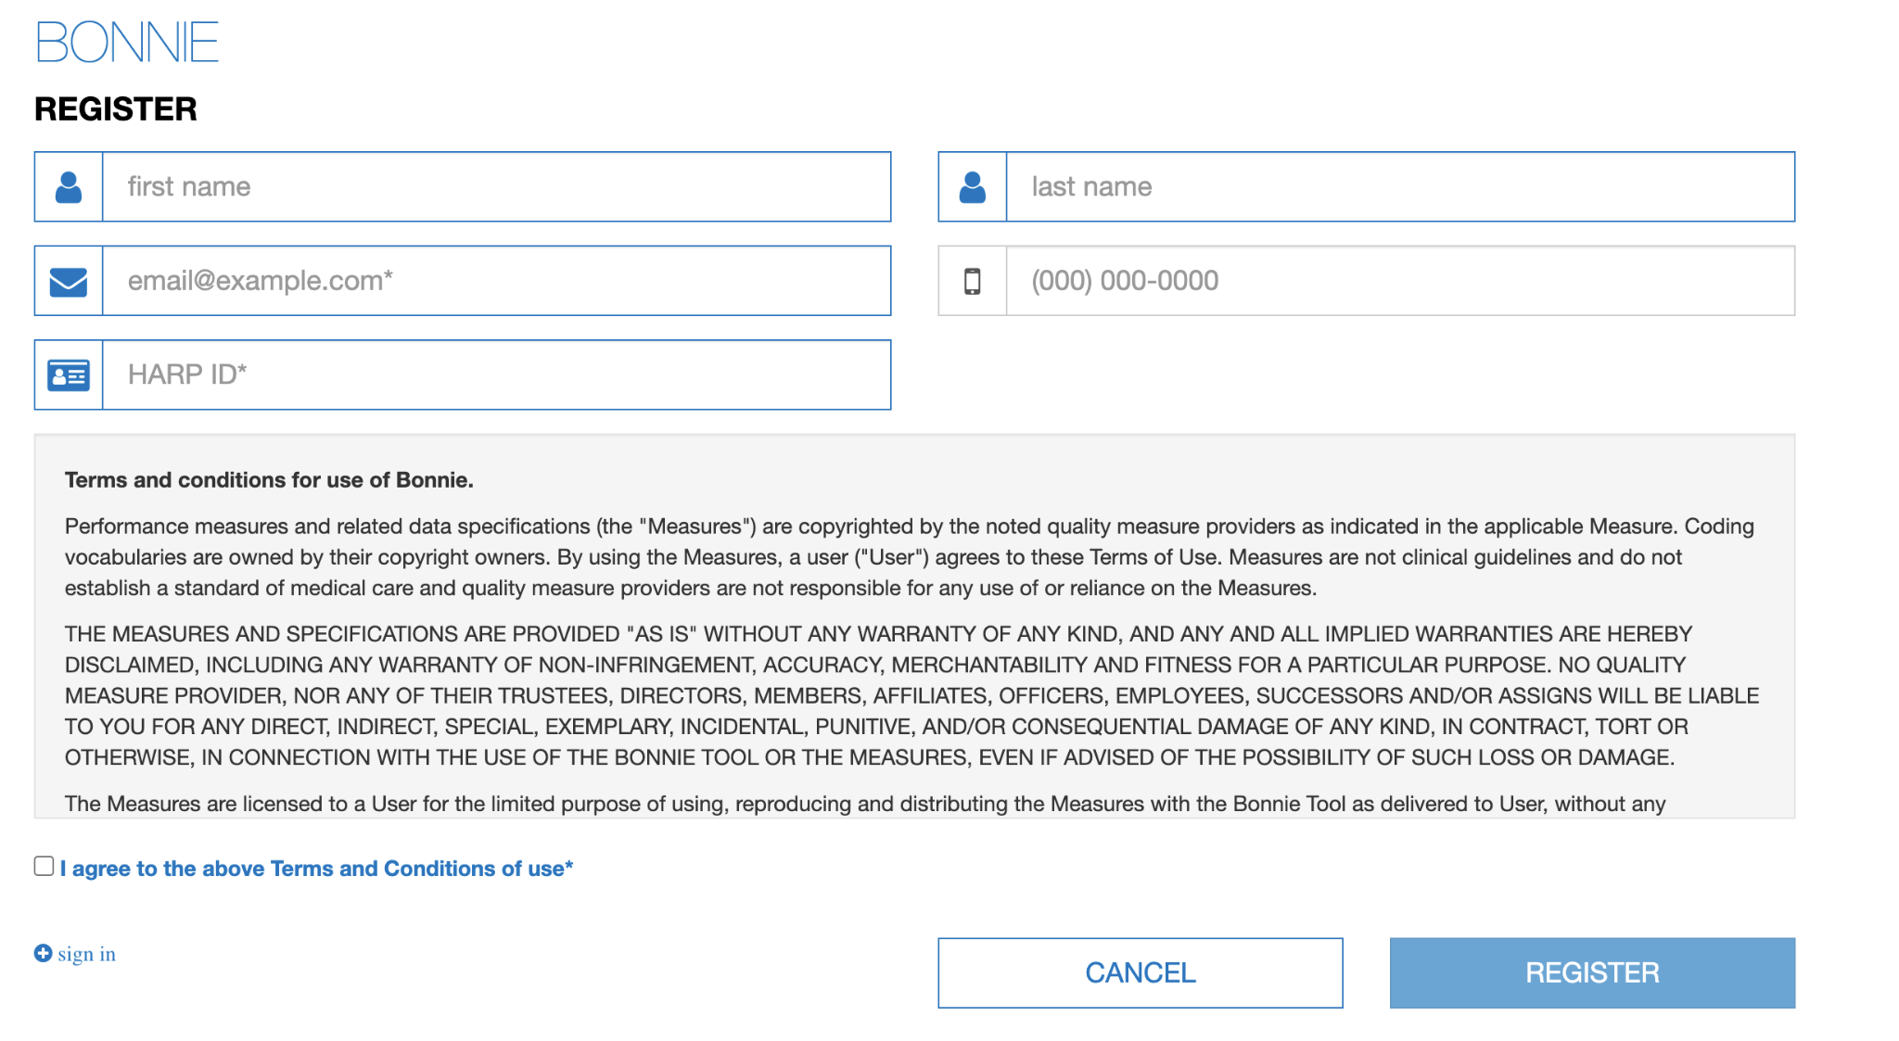

**Figure 1. Bonnie** **Account Registration Page**

## Logging In

After the user's account has been approved they will be able to log in. To log in, navigate to the Bonnie home page and select “Login”. The user will be taken to the HARP login page. Users need to enter their Username and password. Then select the “Agree to our Terms & Conditions”. Finally click “Sign In”.

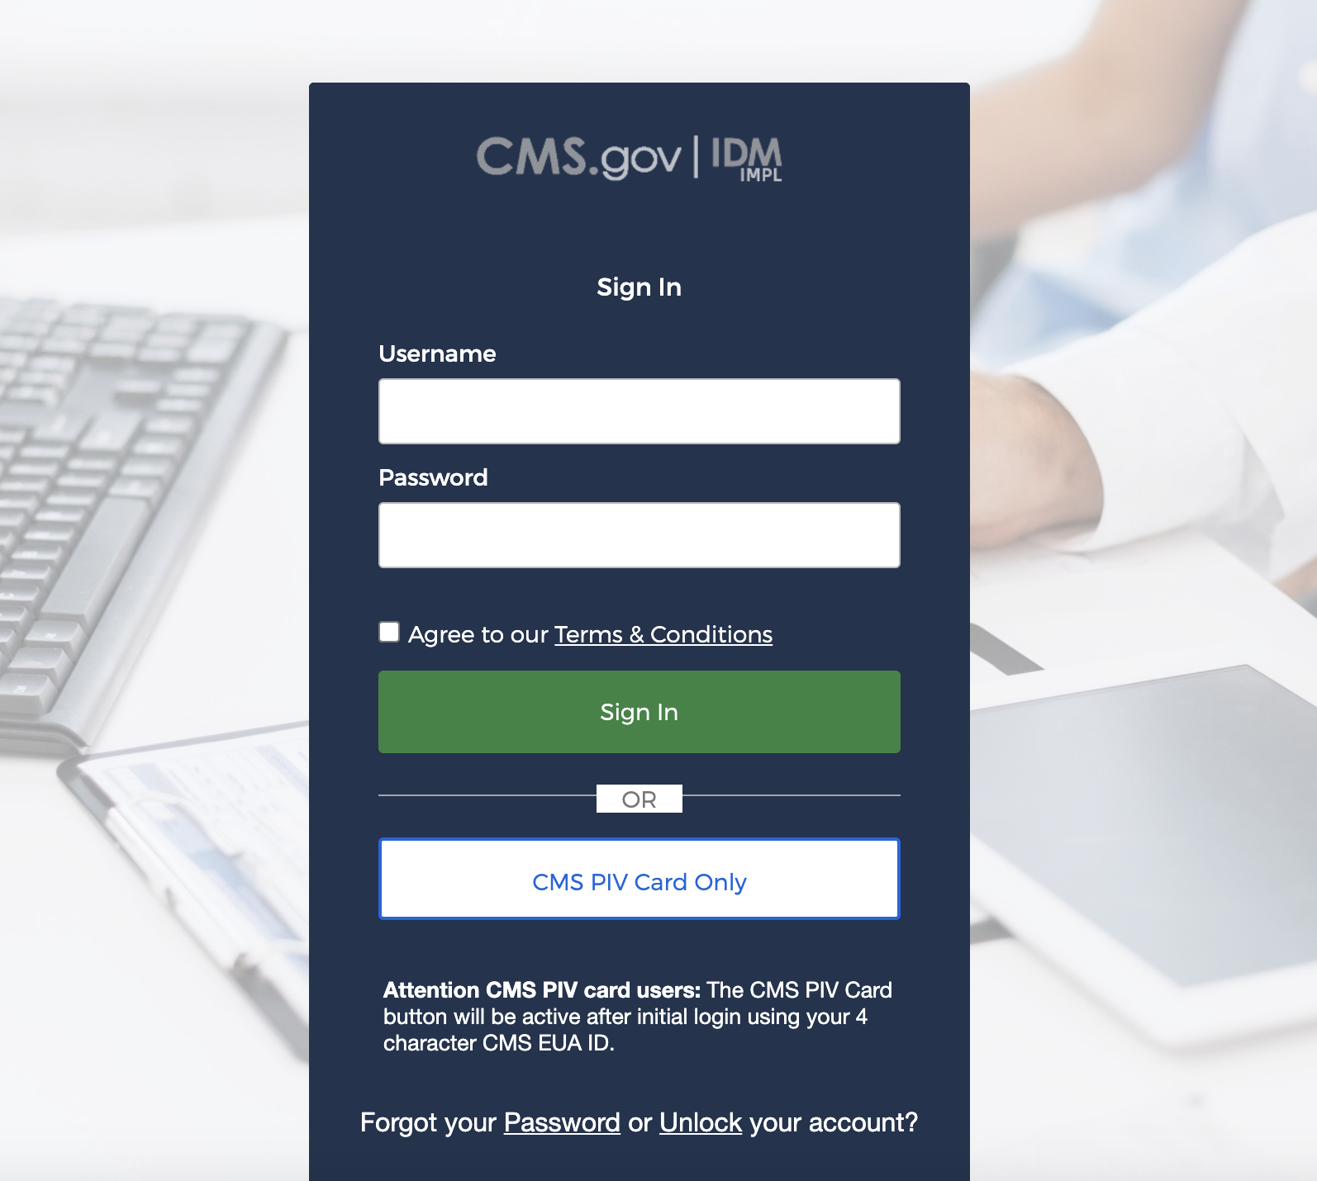

**Figure 2. HARP Login Page**

After clicking “Sign In” the user will be redirected to the two factor authentication page. The user can set up two factor authentication many ways. The example below is an example of Email Authentication. Okta verification, Google Authenticator, SMS Authentication, and Voice Call Authentication are other forms of two factor authentication users can set up. These can be set up, edited or changed via the user's HARP settings. Regardless of the two factor authentication selected, follow through the steps to complete the authentication. On successful two factor authentication, the user will be redirected to their Bonnie Dashboard.

This is a screen shot of the HARP two factor authentication page. This example is for email authentication. Their are no fields, just a text blurb stating that it is for email authentication, the users email (obfuscated), a button labeled "Send me the code" which on click would trigger a code to be sent to the users email. Finally a "Sign Out" link that would sign you out of the tool.

There are fields for entering HARP username and HARP password.  There is a check box for signifying agreement to the Terms and Conditions.  At the bottom are two buttons, "Sign in" and "CMS PIV card only" button, as well as a statement on how to use the PIV card. Finally a two links one if you forgot your password and another to unlock your account.

**Figure 3. Two Factor Authentication Example**

## Logging In - First Time Existing User

When a user logs into Bonnie for the first time using Bonnie 5.0.0 their existing Bonnie accounts will need to be linked with their HARP accounts.

### 2.4.1 Auto Linking Accounts

Auto linking of accounts will happen if the users used the same email address to create their Bonnie account and HARP Account. The user will need to follow the login instructions (section 2.3). On redirect to the Bonnie Dashboard Bonnie will match the existing Bonnie users email automatically. A successful account link message will display.

### 2.4.2 Manual Linking Accounts

If the user has different emails used for the HARP account and Bonnie account, no worries. When the user tries to log in no auto linking will occur. Instead the user will be redirected to the registration page. Here they can either create a new account with the email address that matches their HARP account (Section 2.2) or they can reach out to the Bonnie help desk at [sb-bonnie-help@semanticbits.com](mailto:sb-bonnie-help@semanticbits.com). Users will need to include the email that matches their HARP account and the HARP id and the help desk can manually link the two accounts.

## Resetting a Password

Now that Bonnie utilizes HARP accounts to authenticate users please reach out to the HARP help desk or reset your password on the HARP website.

## Group Accounts

Bonnie 5.0 has a new feature that allows the user to access Bonnie group accounts that they have access to. A group account is an account that holds measures and test cases that many Bonnie users need access to. When a user first logs into Bonnie they will arrive on their private Bonnie Dashboard. This will contain measures and test cases that only that user can access. To switch between groups the user can click on their name. This will open a drop down menu, see Figure 4, containing all the groups the user has access to. Click on the group to switch to a different group. This will load the Bonnie Dashboard screen for that specific group. When uploading a measure or updating a test patient, users need to pay specific attention to which group they are in. As that will be the only group that will see those changes.

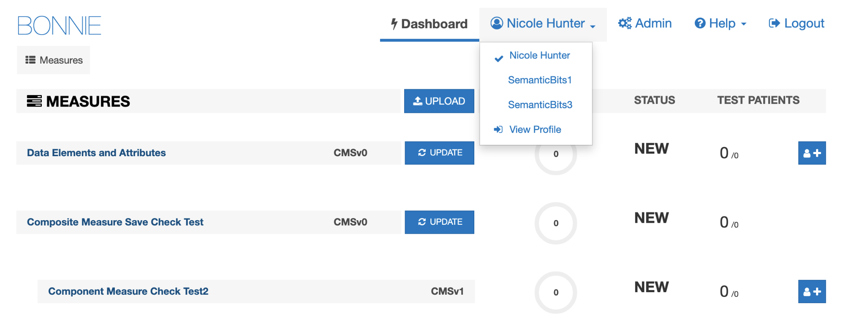

**Figure 4. Group Account Drop Down**

## Account Management

After logging into the application, the user can view the information associated with the Bonnie account by accessing the profile page shown in Figure 5. The profile page can be opened by clicking the “View Profile” link in the group drop down shown in Figure 4. From this page, users can view the information provided to HARP during the registration process. To update this information users will need to visit their profile page on the HARP website. After the user's information is updated on the HARP website the user can log out of Bonnie and log back in and the profile page will be updated.

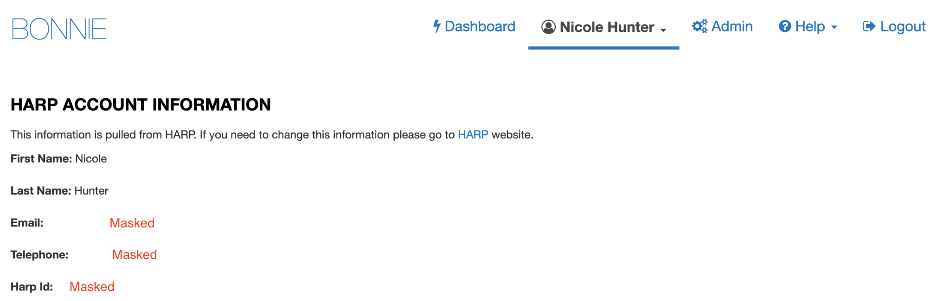

**Figure 5. Profile Page**

# Measure Dashboard

## Overview

The Measure Dashboard page, as shown in Figure 6, is the initial page presented to users when they log into the application. The Measure Dashboard shows the calculation status of each eCQM loaded into the system. The calculation status shows how many patient records have been built for the measure, whether the measure is currently passing or failing, and how many patients are passing or failing for each measure.

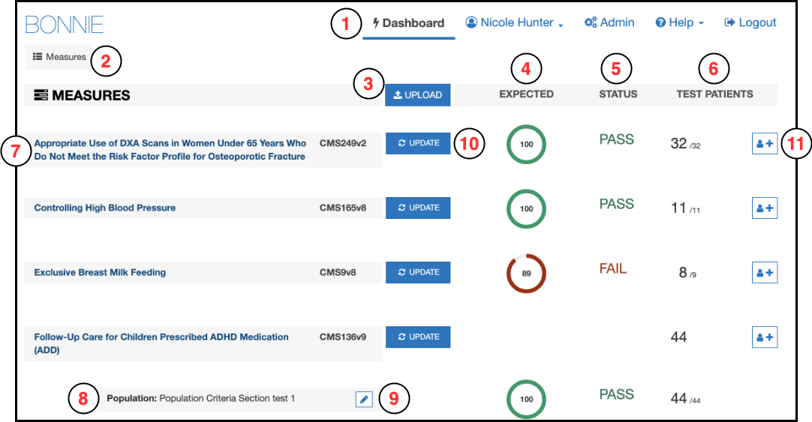

**Figure 6. Measure Dashboard View**

The Measure Dashboard View employs the following user interface (UI) elements (indicated by their item numbers in Figure 6):

1. Header – Allows the user to navigate to different parts of the application, access account information, send a support email (Contact), and log out of the application.
2. Measure Period Date – Displays the measurement period used for calculating eCQMs.
3. Upload Button – Allows the user to upload a new eCQM.
4. Expected Column – Displays the percentage of passing patients for the eCQM.
5. Status Column – Displays the status of the eCQM (New, Pass, Fail).
6. Test Patient Column – Displays the number of patients passing out of the total number of patients.
7. Measure Title – Displays the title for the eCQM and allows navigation to the Measure Dashboard View.
8. Subpopulation and stratification titles – Displays the titles for subpopulations or stratifications of an eCQM.
9. Edit Title Button – Allows the user to rename a subpopulation or stratification.
10. Update Button – Allows the user to update a previously loaded eCQM.
11. Add Patient Button – Allows the user to start building a new patient for an eCQM.

## Loading a New Measure

When users log into the system for the first time, no eCQMs will be associated with the account. The user’s first step is to load an eCQM into the account to begin testing the eCQM with the Bonnie application. The New Measure dialog, as shown in Figure 7, prompts the user to upload an eCQM.

The user may either upload an eCQM now or close this display and upload an eCQM later. After one or more eCQMs have been uploaded, this page displays the current set of eCQMs loaded into the system along with the subpopulations and stratifications associated with the eCQMs. The Measure Dashboard allows users to navigate to the details of individual eCQMs, upload a new eCQM, or update the definition of an existing eCQM. To upload a new eCQM, click the “Upload” button (item #3 in Figure 6) on the Measure Dashboard, which opens the New Measure Dialog shown in Figure 7.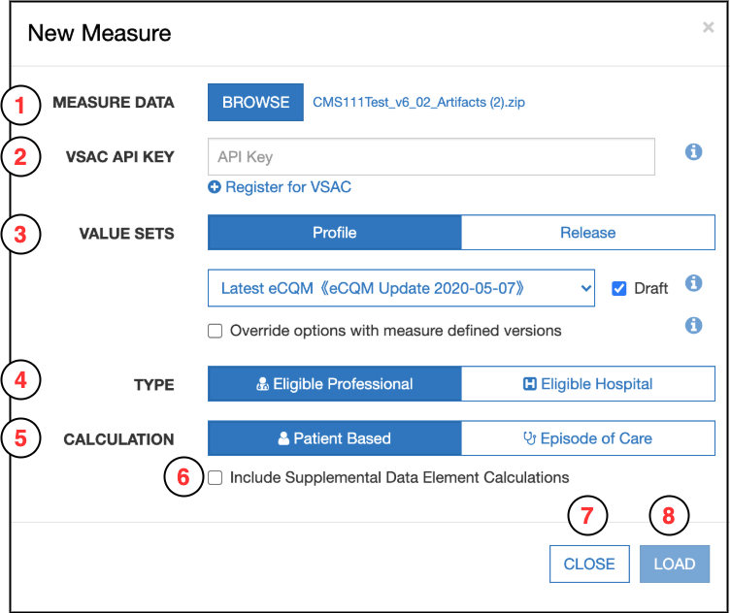

**Figure 7. New Measure Dialog**

After clicking the “Upload” button, the user needs to fill out the information requested from the New Measure Dialog. These fields are outlined below and are indicated by their corresponding item numbers in Figure 7.

1. Browse – Opens a file browser enabling the user to select a MAT measure package to upload into Bonnie.
2. VSAC API Key – Field for entering the user’s VSAC API key to enable Bonnie to load the value sets included within the eCQM. You can find your API key by going to <https://uts.nlm.nih.gov/>, signing in to your UTS account, and clicking “**My Profile.**” If you do not already have an API key, you can generate one by clicking “**Edit Profile**” then checking the box that says “**Generate new API Key**” then clicking “**Save Profile.**”
3. Value Set Options – Options to define which value sets should be downloaded from VSAC. More information about these options is included in subsection 3.2.1.
4. Type – Option to define if the eCQM is an Eligible Professional/Eligible Clinician or Eligible Hospital/Critical Access Hospital eCQM.
5. Calculation – Option to define if the eCQM is a Patient-based eCQM or an Episode of Care-based eCQM.
6. Include Supplemental Data Element Calculations – Option to define if supplemental data elements should be included in calculations and displayed in the supplemental data element section in the eCQM logic.
7. Close – Closes the New Measure Dialog without uploading the eCQM.
8. Load – Uploads the specified eCQM using the selected options.

The action of clicking the “Load” button in the New Measure Dialog uploads the eCQM to the application for processing. Once eCQM loading is complete, the application directs the user to the Measure Dashboard (Figure 6) with the new measure available.

### Value Set Options

Bonnie allows users to download value sets associated with an eCQM based on either a VSAC profile or VSAC release. Bonnie also allows users to download draft value sets (if “Profile” is selected) and/or override their selections with value set versions specified within the CQL logic itself as shown in Figure 8.

**Figure 7. Value Set Options - Profile

Figure 7 presents the Value Set Options view with Profile selected, as described in the text immediately after the figure.**

**Figure 8. Value Set Options – Profile**

Figure 8 shows the Value Set Options section (item #3 in Figure 6) with the default selections. The default selections are “Profile” with the “Latest eCQM” profile selected and “Draft” checked. These default selections have the same behavior as the default selections in Bonnie v2.0. The UI elements included when “Profile” is selected are as follows:

1. Profile – When Profile is selected, Bonnie queries the Value Set Authority Center (VSAC) for value sets calculated by an expansion profile. Expansion profiles are instructions for calculating value set content based on specific code system versions and retired legacy codes.
2. Profile dropdown selector – Allows the user to select an expansion profile to use for retrieving value sets. The default selection is “Latest eCQM <<{profile}>>” where {profile} is the VSAC profile referenced by “Latest eCQM”. In this screenshot, the referenced profile is “eCQM Update 2018-05-04”, so the display shows “Latest eCQM <<eCQM Update 2018-05-04>>”.
3. Override options with eCQM-defined versions – It is possible for an eCQM to contain value set versions within the CQL itself. This option allows the user to override the selected option to use the eCQM-defined value set versions. If this option is selected and a version for a value set is **not** defined within the measure, then Bonnie will use the selected profile to retrieve the appropriate value set version.
4. Draft – When this option is selected, Bonnie will retrieve the draft value set expansions for the selected expansion profile. Note that if the user selects draft and is not an assigned author or steward group member for one or more of the value sets included in the measure, the measure upload will fail. Draft is selected by default.
5. Information buttons – Contains additional information regarding the value set options.

Figure 9 shows the Value Set Options section (item #3 in Figure 7) with “Release” selected.

**Figure 8. Value Set Options - Release

Figure 8 presents the Value Set Options view with Release selected, as described in the text immediately after the figure.**

**Figure 9. Value Set Options - Release**

The UI elements included when “Release” is selected are as follows:

1. Release – When Release is selected, Bonnie queries VSAC for the published value sets associated with the specified release.
2. Program dropdown selector – Allows the user to select the program that includes the release they would like to use.
3. Release dropdown selector – Allows the user to select the appropriate release.
4. Override options with measure-defined versions – It is possible for an eCQM to contain value set versions within the CQL itself. This option allows the user to override the selected option to use the measure-defined value set versions. If this option is selected and a version for a value set is **not** defined within the eCQM, then Bonnie will use the selected release to retrieve the appropriate value set version.
5. Information buttons – Contains additional information regarding the value set options.

## Updating an eCQM

Once the eCQM has been loaded, the testing process may identify issues with the eCQM. When issues are identified, the logic must be updated in the MAT to resolve these issues. Alternatively, the measure could be updated in the MAT as part of an Annual Update. After an eCQM has been updated in the MAT, it may be necessary to update that eCQM in Bonnie for testing. To update an eCQM, follow these steps:

1. Click the “Update” button (item #10 in Figure 6) on the Measure Dashboard, which displays the “Update Measure” dialog as shown in Figure 10.
2. Select a new MAT export zip with the updated eCQM definition.
3. Click the “Load” button to load the new version of the eCQM.

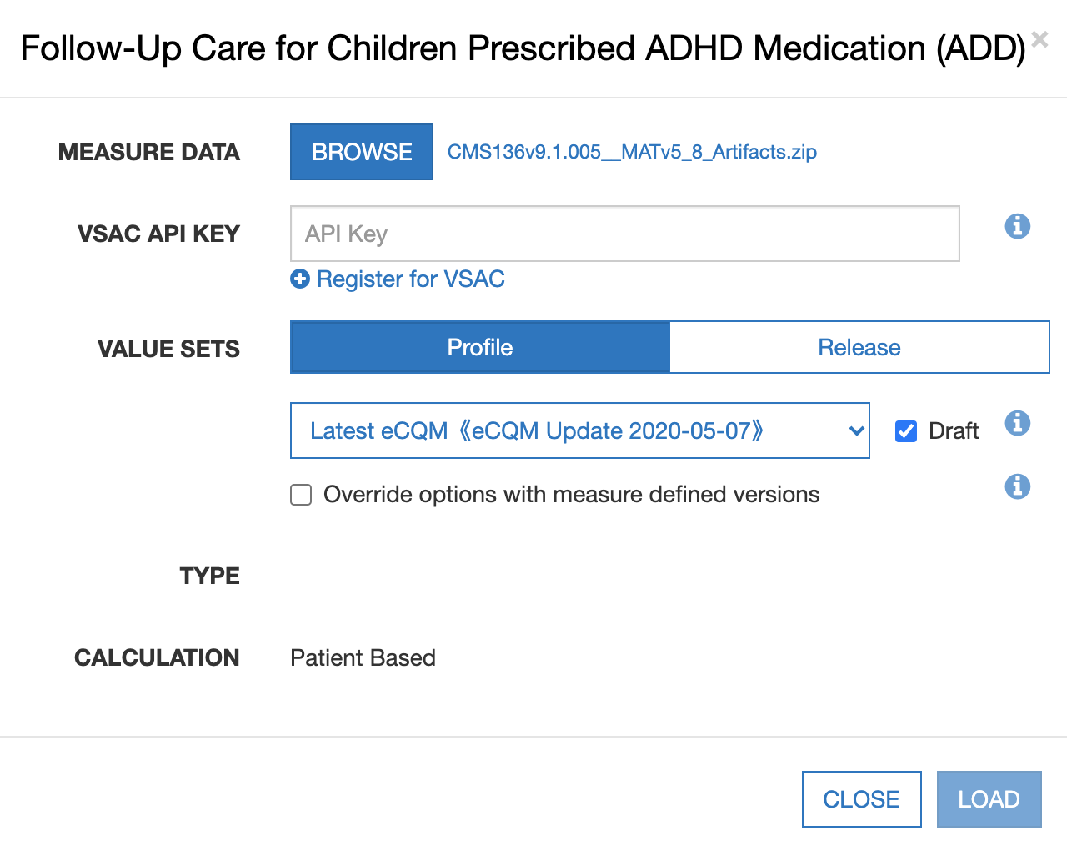

**Figure 10. Updating Measure Dialog**

## Creating Synthetic Test Records

Once a set of eCQMs has been loaded into the Bonnie application, users can start building test patients for the eCQMs. To build a test patient from the Measure Dashboard (Figure 6), click the “Add Patient” button (item #12). This action opens the patient builder screen as shown in Figure 18. For more information, please refer to Section 5, *Building a Patient Test Record.*

After the user creates synthetic test patients for eCQMs, the Measure Dashboard displays summary calculation results of the patients associated with each eCQM loaded by the user (Figure 6). As shown in Figure 6, UI elements numbered 5, 6, and 7 on the Measure Dashboard provide the summary results for each eCQM. In the “Expected” column (item #5), the UI displays the percentage of patients associated with the eCQM whose calculated values meet the expectations set for the patient. The “Status” column (item #6) indicates the current state of the measure—whether it is passing, failing, or new. An eCQM is in the passing state if all associated patients are meeting expectations. If one or more patients are not meeting expectations, then the eCQM is in a failing state. Any eCQM is in the new state when there are no patients associated with it. Finally, the “Test Patients” column (#7) displays the number of passing patients over the total number of patients as a fraction. The measure view, as represented in Figure 11 in Section 4, shows more detailed results for an eCQM.

# Measure Results View

## Overview

As shown in Figure 10, the Measure View page displays the detailed information, associated patients, and calculation results for a single eCQM. In this view, users can add new patients to an eCQM, update an eCQM, and delete an eCQM. To access the Measure View, click on the “Measure Title” link (item #7) on the Measure Dashboard, as shown in Figure 6.

The Measure View page presents the title and description of the eCQM, the logic for the eCQM, and a measure complexity indicator. The page lists the current set of test patients associated with the eCQM in the column on the right-hand side of the page. This column displays the summary calculation results for the patient test deck associated with the eCQM along with the list of patients and the individual calculation results for each. This page also shows the results of calculation for a single patient along with an overlay of the calculation results on the eCQM logic.

The following UI elements appear at the top of the Measure View page (indicated by their item numbers in Figure 11):

1. Measure Title – Displays the title and description of the eCQM.
2. Measurement Period – Displays the current Measurement Period and allows the user to update the Measurement Period.
3. Measure Actions – Allows the user to delete or update an eCQM definition.
4. Measure Subpopulations or Stratifications – Allows access to different subpopulations or stratifications in the eCQM.
5. Measure Logic – Displays a representation of the logic for the eCQM.
6. Logic Highlighted With Coverage – Displays the logic for the eCQM, highlighting which lines of the eCQM are covered by the test patients.
7. Patient Actions – Allows the user to import JSON patient records, convert patients to FHIR (disabled for Bonnie 5.1.0), export patient records in a JSON format, QRDA format (disabled for Bonnie 5.1.0), Excel format, or Delete all Patients. Note: See section 6 for workflow on Export/Import of JSON patient records.
8. Percent Successful – Displays the percent of patients currently meeting expectations for the eCQM.
9. Patients Passing Count – Displays the current number of patients meeting expectations over the total number of patients in the test deck for the eCQM.
10. Test Coverage – Displays the percentage of the measure logic that has been evaluated to true for the patient test deck. This measure provides a method for determining how much of the logic has been tested.
11. Add Patient – Allows the addition of a new patient to the test deck for this eCQM.
12. Failing Patient – Displays an example of a patient that is not currently meeting expectations for the eCQM.
13. Passing Patient – Displays an example of a patient that is meeting expectations.
14. Patient Name – Displays the name given to the patient.
15. Patient Status – Displays PASS or FAIL to indicate if the patient is meeting expectations.
16. Expand Patient Results Button – Displays the calculation details of a patient. This display will show the expected and actual values for the patient against the eCQM.
17. Show Result – If a patient has been selected with the Expand Patient Results Button, this displays the result of the logic evaluated on the selected patient.
18. Show All Results – If a patient has been selected with the Expand Patient Results Button, this displays the result of each eCQM logic block evaluated on the selected patient.

Figure 10: Measure View

Figure 10 depicts the UI elements in the Measure View page in Bonnie as described in the text immediately preceding the figure.

**Figure 11. Measure View**

The following UI elements (indicated by their item numbers in Figure 12) appear at the bottom of the Measure View Page:

1. Terminology – Displays the value sets from the eCQM and referenced libraries. Clicking on any one of these value sets will show the list of codes associated with that value set.
2. Overlapping Value Sets – Displays value sets in the eCQM and referenced libraries that have shared codes.

Figure 11: Measure Terminology and Overlapping Value Sets

Figure 11 depicts the UI elements in the Measure Terminology and Overlapping Value Sets sections in the Measure View page in Bonnie as described in the text immediately preceding the figure.

**Figure 12. Measure Terminology and Overlapping Value Sets**

## Measure Logic

The left-hand side of the Measure View contains the measure title, description, and a representation of the logic. The representation of the eCQM logic is similar to the human-readable display for the eCQM provided in the MAT measure exports.

The eCQM logic section can be used to verify that the eCQM logic was properly loaded from the HQMF without the loss of any logical conditions. The logic can also be used to evaluate the nature of the calculation of a test patient against the logic (please refer to subsection 4.4, *Calculation Results*) and to visualize the test coverage of the eCQM logic.

## Creating a New Test Record

To create a new test record, begin by clicking the “Add Patient” button (item #9) in the Measure View (Figure 11). This action opens the Patient Builder (shown in Figure 18). After creating the test patient record, the application returns the user to the Measure View where the user can evaluate the results of calculating the patient against the eCQM.

## Calculation Results

The user can calculate the test patient against the logic of the eCQM in the Measure View (Figure 11). High-level results are calculated automatically when the Measure View is loaded. These high-level results appear under the test patients section on the right-hand side of the Measure View. These results include the percent of patients passing (item #6), the test coverage (item #8), individual statuses for each patient (items #10–13), and the passing patient count (item #7).

In addition to these high-level results, detailed results can be displayed for an individual patient by clicking the “Expand Patient Results” button (#16). This displays a table of expected and actual results for the patient covering each population listed in the measure and shows whether that population currently meets or fails expectations.

The Expanded Results View employs the following UI elements (as indicated by their item numbers in Figure 13):

1. Failing Population – A population for which the patient fails.
2. Passing Population – A population for which the patient passes.
3. Population Column – A list of the population types.
4. Expected Value – The user-defined expected value for the population.
5. Actual Value – The calculated value for that population.
6. Edit Patient Button – Allows editing of the selected patient.
7. Clone Patient Button – Allows cloning of the selected patient.
8. Delete Patient Button – Allows deleting of the selected patient.

**Figure 12: Expanded Results View

Figure 12 shows the Expanded Results View as described in the text immediately preceding the figure.**

**Figure 13. Expanded Results View**

Clicking the “Expand Patient Results” button also displays the patient results calculated against each line of logic. This information is displayed in the measure logic section of the view by highlighting each logic clause. As shown in Figure 14, Figure 15, and Figure 16, a green highlight (accompanied by a solid underline) indicates a passing result for the logic calculation, while a red highlight (accompanied by a double-underline) indicates a failing result over the applicable lines of text.

**Figure 13: Logic Calculation Highlight - Passing Results

Figure 13 depicts the logic calculation highlight (passing results) for the Initial Population as described in the paragraph immediately following the figure.**

**Figure 14. Logic Calculation Highlight – Passing Results**

Figure 14 shows the results of a single patient calculated against the eCQM logic. The highlighting of the eCQM logic text for calculation is intended to provide a clearer understanding of why a patient is calculating to a specific population, and uses the following indications of status:

* Logic evaluated to TRUE – Green highlighting along with a solid underline
* Logic evaluated to FALSE – Red highlighting along with a double underline

The results of the calculation in Figure 13 are that the patient aligns with the logic of the initial patient population (IPP). The highlighting of the logic in Figure 14 indicates that every AND condition evaluated to true and at least one condition from each OR evaluated to true. Based on this calculation, the “Inpatient Encounters” definition evaluates to true for the patient.

The “Show Result” button at the bottom of Figure 13 can be used to expand the result, as shown in Figure 15. To collapse the results, click the “Hide Result” button.

**Figure 14. Logic Calculation – Expanded Result

Figure 14 shows the expanded result, which displays information regarding the result of the test (defined above) evaluated on the selected patient.**

**Figure 15. Logic Calculation Highlight – Expanded Result**

In Figure 15, the bottom grey box displays information regarding the result of the eCQM logic definition evaluated on the selected patient. In the example shown, the “Inpatient Encounters” definition looks for encounters in a certain time range. The grey box will display all encounters that meet that criteria; in this example, the selected patient has one encounter that meets the criteria.

In Figure 16, the population is highlighted in red, indicating that the logical statements evaluate to false. Some clauses in this figure are green, indicating they are true; however, the false female statement causes the AND logic to be false, and therefore, the results calculated in Figure 16 indicate that the patient is neither included in the IPP nor the Denominator.

**Figure 15: Logic Calculation Highlight - Failing Results

Figure 15 depicts the logic calculation highlight (failing results) for the Initial Populationas described in the paragraph immediately following the figure.**

**Figure 16. Logic Calculation Highlight – Failing Results**

## Editing a Test Record

The user can edit a test patient from the Measure View (Figure 11) by clicking the “Edit” button. The user accesses the “Edit” button for a patient (item #6 in Figure 13), accessible after expanding the patient result. Clicking the “Edit” button opens the Patient Builder (as shown in Figure 18 ) with the data populated for that patient. Once a patient record has been edited and saved, the application returns the user to the Measure View.

## Cloning a Test Record

The user can clone a test patient from the Measure View (Figure 11) by clicking the “Clone” button (item #7 in Figure 13) to the immediate right of the “Edit” button, accessible after expanding the patient result. This action opens the Patient Builder (Figure 18) with the data populated for the patient being cloned. The difference between editing and cloning a patient is that the clone process creates a new patient based on an existing patient, while the edit process updates the data for an existing patient. Once a patient record has been cloned, edited, and saved, the application returns the user to the Measure View.

## Deleting a Test Record

The user can delete a test patient from the Measure View (Figure 11) by clicking the “Delete” icon (item #8 in Figure 13) to the immediate right of the “Clone” button, accessible after expanding the patient result. Deleting a patient requires a two-step process for confirmation. Once a user deletes a patient record, the action cannot be undone. To delete a patient record, the user initially clicks the “Delete” button. A second “Delete” button is then displayed. The user must click the second “Delete” button to confirm the deletion of the patient.

## Updating a Measure

The user can update a measure by clicking the “Update Measure” button, which is accessed by clicking the “Measure Actions” icon (item #3 in Figure 11). The “Update Measures” button displays the Update Measure Dialog (shown in Figure 10), which allows the user to specify a new zip package for an eCQM exported from the MAT. Once the new measure package has been entered, the user clicks the “Load” button, which updates the eCQM definition and returns the user to the Measure View with the updated measure definition.

## Deleting a Measure

The user can delete an eCQM from the Measure View (Figure 11) by clicking the “Delete” icon for an eCQM. To access the “Delete” icon, the user clicks the “Measure Actions” icon (item #3 in Figure 11). A user cannot undo the deletion of an eCQM. To delete an eCQM, the user initially clicks the “Delete” icon. A second “Delete” icon is then displayed. The user must click the second “Delete” icon to confirm the deletion of the eCQM. Deleted eCQMs are no longer displayed on the Measure Dashboard.

## Updating Measurement Period

The user can modify the Measurement Period associated with the Measure from the Measure View (Figure 11) by clicking the “Measurement Period” button (item #2). Once the user clicks the button, a dialog will appear (Figure 17) which allows the user to input a new Measurement Period. In addition to modifying the Measurement Period, the user also has the option to shift all dates on the patient history by the same number of years that the measurement period will shift.

Figure 16. Change Measurement Period

Figure 16 presents the Change Measurement Period Dialog as described in the text immediately before the figure.

**Figure 17. Change Measurement Period**

## FHIR Patient Export

This version of Bonnie QDM does not currently support FHIR Patient Export. This will come at a later time. Bonnie Prior will still support FHIR Patient Export, please visit the Bonnie Prior User Guide located [here](https://bonnie-prior.healthit.gov/resource/Bonnie_user_guide.pdf), for instructions on how to convert QDM 5.5 patients to FHIR.

# Building a Patient Test Record

## Overview

The Patient Builder view, as shown in Figure 18, allows the addition and editing of clinical data for a synthetic test patient record. The user accesses the Patient Builder view by clicking the “Add Patient” button (item #11) on the Measure Dashboard (Figure 6), or by clicking the “Add Patient,” ‘Edit,” or “Clone” buttons from the Measure View (Figure 11).

The Patient Builder View employs the following UI elements (as indicated by their item numbers in Figure 18):

1. Patient Name – Allows the entry of a first and last name for the patient record.
2. Patient Characteristics – Allows the definition of characteristics data for the patient.
3. Measure Information – Shows the description for the patient’s associated eCQM.
4. Expectations – Allows users to set the calculation expectation for each population of the eCQM.
5. Actions – Allows users to save or cancel a patient record.

Figure 17: Patient Builder View

Figure 17 shows the Patient Builder View as described in the text immediately preceding the figure.

**Figure 18. Patient Builder View**

The Patient Builder view also provides fields to either add new data or edit existing data for a patient. The patient’s first and last names can be defined using the associated edit fields. Characteristics such as gender, birthdate, race, and ethnicity can be set in the characteristics section. Quality Data Model elements can be added to the patient history section by dragging and dropping an individual element onto the patient history section.

In addition to defining the patient data, the Patient Builder view allows the user to set expectations on the patient using the “Expectations” section. Expectations represent how the user expects the patient to calculate against the eCQM. The “Expectations” section will be different based on the type of eCQM used to build the patient record. The “Expectations” section for patient-based eCQMs provides a check box for users to select the appropriate expected populations (e.g., numerator, denominator) within which the patient will be included. The “Expectations” section for episode of care-based measures allows users to select the number of episodes of care that are expected to be included in each population using a number picker. Continuous variable measures allow users to define the expected value(s) the measure is expected to calculate for the patient.

The Patient Builder’s logic section displays the logic of the eCQM against which the patient test record is constructed. As data is entered, the application continuously calculates the patient against the eCQM logic, and the results are displayed against the eCQM using the logic highlighting. Subsection 4.4 provides additional information about the descriptions of the logic highlighting technique based on calculation results shown in Figure 14 and Figure 16.

## Building a Synthetic Patient

The first step in building a synthetic patient record is defining the patient name. The patient’s first and last name can be set in the “Patient Name” section (item #1 in Figure 18). The user can then add patient notes and define patient characteristics in the “Patient Characteristics” section (item #2). Characteristics for the patient include data such as birthdate, race, ethnicity, gender and living status.

After defining the patient’s name, the user defines the expectations for how the patient will behave and be calculated against the eCQM. The user sets the expectations for the patient in the “Expected Value” section (item #4). If the user expects the patient to align with the initial patient population logic, then the user should set that expectation in item #4. Expectations are used throughout the Bonnie application to determine if a patient is passing or failing against the eCQM.

If the expected results for the patient align with the actual results from calculating the patient against the eCQM logic, the patient passes. If the expected results do not match the actual calculated results, the patient fails. This system provides the capability to build patients and set expectations for those patients based on the intent of the eCQM. Once the eCQM is calculated, the passing state indicates that the eCQM logic aligns with the intent, while the failing state indicates that either the eCQM logic does not align with the intent or the synthetic patient was constructed improperly.

Note that in Figure 18, the depicted measure has a discrete expected value. Accordingly, the NUMER, DENOM, and DENEX options are shown. For continuous variable measures that rely on an aggregate calculation (e.g., a median time between ED arrival and ED departure), the OBSERV, MSRPOPL, and (optionally) MSRPOPLEX options are shown, as in Figure 19. For continuous variable measures that rely on more than one aggregate calculation, more than one OBSERV option will show under Expected Value. Note that the numbering of the OBSERV options may not align with the numbering of the Measure Observations in the measure package Human Readable file exported from the Measure Authoring Tool.

**Figure 18: Continuous Variable Measures Expected Populations

Figure 18 shows a screen capture of continuous variable measures expected populations as described in the text immediately preceding the figure. The checkboxes for IPP and MSRPOPL are checked with the OBSERV option set at 50.**

**Figure 19. Continuous Variable Measures Expected Populations**

Although discrete measures offer only a checkbox for including patients in the NUMER population, continuous variable measures offer the ability to set a certain percentage or minute value for a given patient calculation. This value is only available if the patient is in the MSRPOPL population.

## Building the Patient History

Figure 19 depicts four events in the patient’s history—an encounter, a diagnosis, and two medications—based on data elements from the eCQM. When a QDM element is added to the patient history, it becomes an event in the patient’s history, which warrants a duration and associated fields. When an event is first created, it is given default start and end date/times and is associated with a code from each value set associated with the source QDM element. These defaults as well as additional data can be edited by expanding the event. Figure 20 shows an example of an expanded event from the patient history that can be edited. By clicking the expand/collapse details icon (item #3), the user can edit the details of the element.

The following UI elements are shown in Figure 20:

1. Elements Section – Contains QDM elements that the user can add to the patient history.
2. QDM Element – Shows a condensed summary of a QDM element.
3. Expand/Collapse Details – Allows hiding or expanding the details of an element.
4. Start Date/Time – Allows setting the start date/time for an element. The checkbox allows specifying that the start date/time is undefined.
5. End Date/Time – Allows setting the end date/time for an element. The checkbox allows specifying that the end date/time is undefined (ongoing event).
6. Codes Section – Allows adding codes to the element. Note that Bonnie will automatically find an appropriate code and add it.
7. Attributes – Allows adding fields to the element (i.e., Result, Diagnoses).
8. Negation Section – Allows indicating that the element is not done with a reason.
9. Delete Button – Allows deleting an element from the patient history.
10. CQL Calculation Results – Shows the results for each of the populations.
11. Show Result – Displays the result of the logic evaluated on the patient.
12. Show All Results – Displays the result for each eCQM logic block evaluated on the patient.

**Figure 19: Building Patient History, including Edit Clinical Element View

Figure 19  shows a screen capture for building patient history, as described in the text immediately preceding the figure.**

**Figure 20. Building Patient History, Including Edit Clinical Element View**

After the user defines the patient characteristics, the user builds a patient history from QDM elements extracted from the eCQM. The available elements from the eCQM are organized by category and listed in the “Elements” section (item #1). The user can click a category to expand the list of available elements. Expanding this list allows the user to click and drag an individual element onto the patient history (item #2).

Several fields in the Edit Clinical Element View can be edited for an event in the patient history using the controls shown in Figure 20. These fields include the start date/time of the event (items #4 and #5), codes (item #6), various fields (item #7), and negation rationale (item #8). The start and end date times can be set for an event by either typing into the text fields directly or by using the date/time pickers that are displayed when the field is selected. An undefined start time and end time can be set for the event (used for active or ongoing events) by selecting the “Undefined” checkbox. Selecting the “Undefined” check box clears the date/times, indicating that the event has not started/ended.

Attributes and negation rationale also can be set for an event. Attributes such as ordinal, severity, discharge date/time, etc. can be added using the “Attributes” section. Attributes are added by selecting the type of the field (scalar, coded, or time) and entering a scalar value, selecting a value set, or entering a date.

Negation rationale can be defined for the event to indicate that the event was not done for a specific reason. Negation rationale is added by clicking the “Not Performed” checkbox in the negation section and selecting a value set representing the reason the event was not done.

Finally, events can be removed from the patient history by clicking the “Delete” icon (item #10). Deletion requires a two-step process. After initially pressing the “Delete” icon, the user is prompted to depress the “Delete” icon a second time to confirm the deletion.

## Incremental Calculation

The final section of the Patient Builder View is the logic section. This section displays a representation of the logic for the eCQM against which the patient is constructed. The logic can be a reference to help describe the details of the data that should be added in building the synthetic patient.

The logic section continuously displays the results of calculating the patient against the eCQM by means of the logic highlighting described in Figure 14 and Figure 16. Any modification made to a patient triggers a recalculation of the patient against the eCQM, which updates the results of the calculation displayed by the logic highlighting. Therefore, while the user constructs the patient record, the user can inspect the behavior of the logic relative to the patient.

When the user has completed constructing a synthetic patient, the user clicks the “Save” button in the Patient Builder View. This action adds the patient to the test deck for the measure and returns the user to the Measure View. After the user creates the first patient, additional patients can be created from scratch or cloned from existing patients to extend the coverage of the test deck against the eCQM.

# Export/Import Patient Workflow

Bonnie now allows users to export and import test patients in JSON format. This feature will allow users to easily move patients around from one measure to another as well as one Bonnie account or group to another.

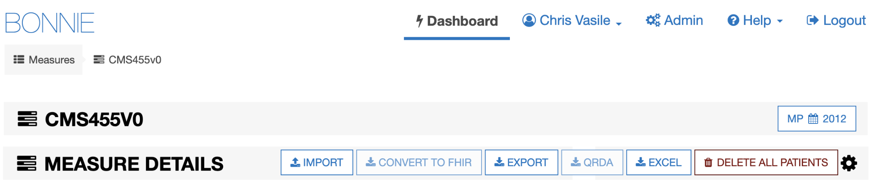

**Figure 21. Patient Action Row**

## Export Patients

Patients can be exported for a specific measure. Navigate to the measure containing the patients to export. Select the patient action icon (Figure 11, Item 7) and select “Export” from the Patient Action Row (Figure 21). Bonnie will now export all test patients in the measure into a JSON file. That JSON file will then be zipped and downloaded to the user's computer. A success message will then be displayed to the user (Figure 22).

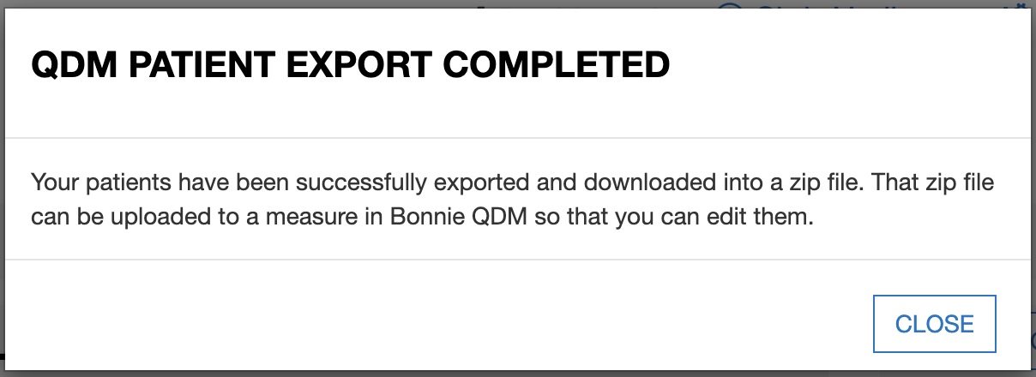

**Figure 22. Successful Patient Export Message**

* 1. **Import Patients**

Users can take the zip file created in step 6.1 and Import them into a different measure or Bonnie account or group. Navigate to the measure where the patients need to be imported. Select the patient action icon (Figure 11, Item 7) and select “Import”. A modal will pop up allowing the user to select the specific zip file created in step 6.1 they wish to import (Figure 23). Users should click “Choose File” and navigate their computer to locate the desired zip file. After selection, click “Submit”.

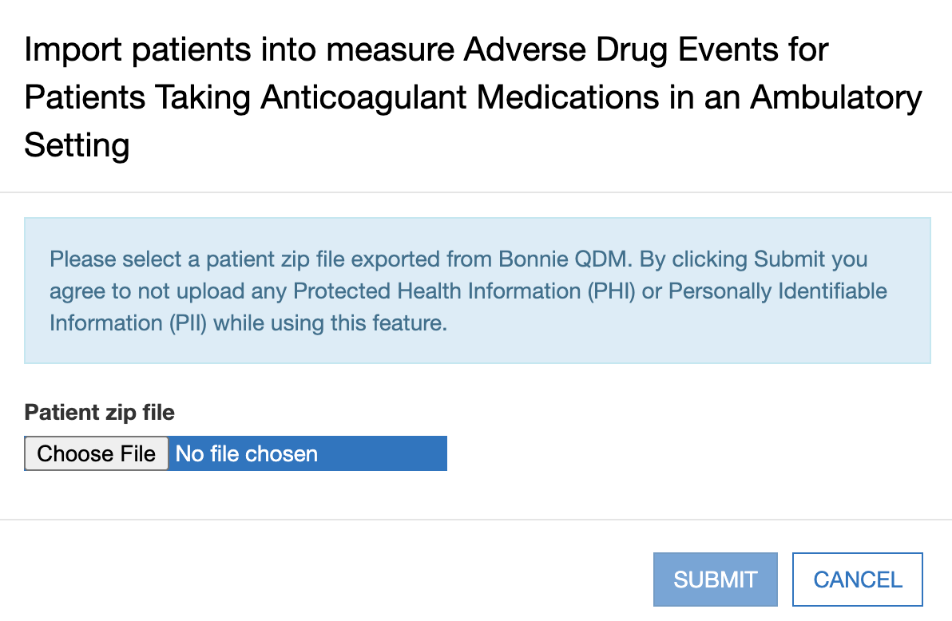

**Figure 23. Patient Import File Selector**

Patients can be successfully uploaded in two ways. The first way will import all the patients as well as the expected values. This will occur when the populations the patients contain match the populations the destination measure have (ie. the imported patients and the destination measure both only include Initial Population, Denominator, and Numerator). A success message will appear (Figure 24). Secondly, all the patients will be imported, but the expected values will not be imported. This will occur if the populations in the imported patients and the destination measure do not match (ie. the imported patients have a denominator exclusion while the destination measure does not). A success message will still appear (Figure 25).

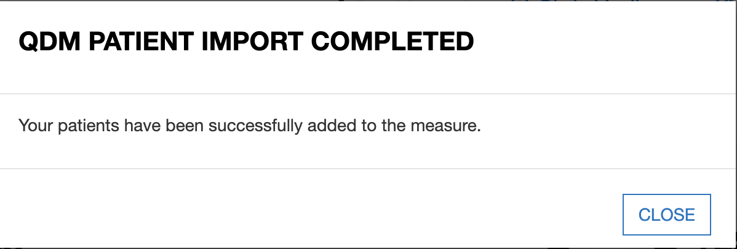

**Figure 24. Successful Patient Import; Expected Values Copied**

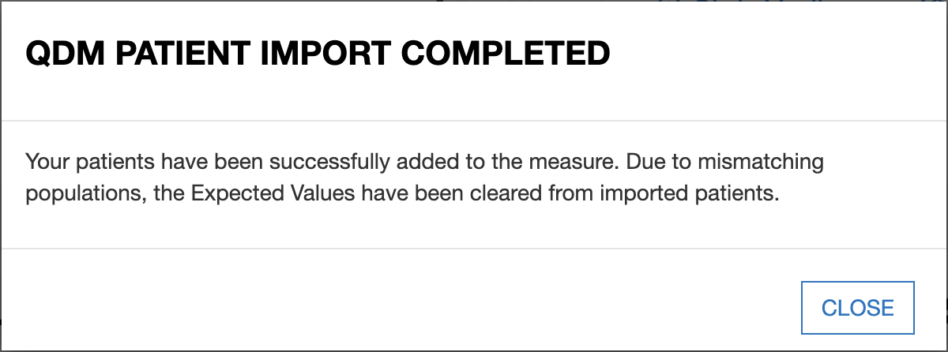

**Figure 25. Successful Patient Import; Expected Values Dropped**

Patient import can also fail. Zip files must have been exported from the same QDM version, if not the import will fail. The Bonnie team also recommends against importing any patient JSON files that have been edited. Using edited files may cause unexpected results.

# Feedback and Support

An issue tracker and feedback email list are available to support the resolution of issues and to answer questions related to the Bonnie application. The Bonnie issue tracker is available on the ONC Jira system at: <https://oncprojectracking.healthit.gov/support/projects/BONNIEMAT/summary>

When users encounter bugs in the Bonnie application, they should use the issue tracker to report bugs, ask questions, or to request new features. To add an issue, users must create a login account in the Jira system. Once an issue has been entered, the Bonnie team will review and prioritize it.

# Frequently Asked Questions

**Does Bonnie replace Cypress or is it an alternative to Cypress for certification?**

No. Bonnie is a testing tool for measure developers to test eCQMs as they are being authored, while Cypress is the CMS quality reporting program certification tool. Bonnie cannot be used for CMS quality reporting program certification for vendors.

Bonnie provides insight into the details of how eCQM logic behaves. This makes it useful to vendors, measure developers, and others in the eCQM space who would like to better understand the behavior of eCQMs. The Bonnie testing tool uses the same measure calculation engine as the Cypress tool. Therefore, Bonnie can be used to better understand the behavior of the eCQMs when implementing an eCQM prior to certification.

**Can I export patient records from Bonnie?**

Users can currently export test patients constructed using Bonnie in a human readable format as well as a JSON format. In the future Bonnie will be able to export in the QRDA format, and FHIR patient format.

**Can I load patient records into Bonnie?**

Currently, Bonnie only allows import of patient records into Bonnie that were exported from Bonnie, see section 6 for more details.

**Does Bonnie automatically generate patient records?**

Currently, Bonnie does not offer the capability to automatically generate patient records based on the eCQM logic. The goal of Bonnie is to allow the construction of carefully considered patient scenarios. These synthetic patient records are intended to have an expected result based on the intent of the eCQM. Automatically generating patient records would generate patients that align with the eCQM logic as written, but if there were issues in the eCQM logic, these patients might not align with the intent of the eCQM.

**My patient does not match the logic of the Initial Population. Why is the patient passing?**

A test in Bonnie is based on assigning an expected outcome to a synthetic patient record based on the intent of the eCQM. A patient can be constructed with the expectation that the patient calculated is to be included in the Initial Patient Population. If the patient actually calculates to the Initial Patient Population, then the test passes. If the patient does not calculate to the Initial Patient Population, then the test fails.

There must be an exact match between the patient’s alignment and the expectation’s needs. For instance, if the expectation is set for only the Initial Patient Population, and the patient calculates to the Initial Patient Population and the Denominator, the test fails. Similarly, a patient can be constructed with the expectation that the patient does not align with any of the eCQM populations. In this case, if the patient does not calculate into the Initial Patient Population, the test will pass. If a patient is constructed with the expectation set of not aligning with any of the eCQM populations and that patient calculates into the Initial Patient Population, that test will fail.

**Where can I get help with Bonnie?**

The Bonnie application has a Help menu in the header. Once you log into the application, you can use the help menu to send an email to the Bonnie feedback list to (a) ask a question directly; (b) access the Bonnie issue tracker to enter a bug, ask a question, or request a feature; and (c) access the user guide that provides step-by-step instructions on using the Bonnie tool.

**What measure formats can I load into the Bonnie tool?**

The Bonnie application can load CQL 1.5 measure packages from the Measure Authoring Tool using the QDM 5.6 model. Note that when loading, you will need a National Library of Medicine (NLM) Value Set Authority Center (VSAC) account (<https://uts.nlm.nih.gov/license.html>) to download the value sets associated with the measure.

**Do I have to be a measure developer to use the Bonnie tool?**

No. Anyone can sign up for a Bonnie account. Follow the steps laid out in section 2.2.

**Do I need to be a Measure Authoring Tool user to use the Bonnie tool?**

No. eCQMs can be loaded into the Bonnie tool either by using a Measure Authoring Tool zip file export or by loading measures released to the CMS website. Loading eCQMs using a MAT zip file export will require a MAT account to download the export zip; however, if you do not have a MAT account, you can use the released versions of the eCQMs from the eCQM Library page on the CMS website once they are published.

**Can Bonnie be used to calculate the results for a large number of patient records?**

Bonnie is not designed to handle calculations for more than a few hundred patient records per measure. If you are interested in calculating eCQMs against a larger number of patient records, the popHealth tool may be a better solution.

**What version of the CQL Execution Engine Does Bonnie use?**

Bonnie currently uses CQL Execution Engine version 2.3.3. Updates and what is included in this version can be found [here](https://github.com/cqframework/cql-execution/releases/tag/v2.3.3).

**Acronyms**

| **Acronym** | **Definition** |
| --- | --- |
| **CMS** | Centers for Medicare & Medicaid Services |
| **CQL** | Clinical Quality Language |
| **CQM** | Clinical Quality Measure |
| **eCQM** | Electronic Clinical Quality Measure |
| **ED** | Emergency Department |
| **EH** | Eligible Hospital |
| **EP** | Eligible Professional |
| **HHS** | Department of Health and Human Services |
| **HQMF** | Health Quality Measure Format |
| **HTML** | Hypertext Markup Language |
| **IPP** | Initial Payment Population |
| **JSON** | JavaScript Object Notation |
| **MAT** | Measure Authoring Tool |
| **NLM** | National Library of Medicine |
| **ONC** | Office of National Coordinator for Health Information Technology |
| **QDM** | Quality Data Model |
| **QRDA** | Quality Reporting Document Architecture |
| **UI** | User Interface |
| **UMLS** | Unified Medical Language System |
| **VSAC** | Value Set Authority Center |
| **XML** | Extensible Markup Language |

1. Cypress is the rigorous and repeatable testing tool of Electronic Health Records (EHR) and EHR modules used in calculating electronic clinical quality measures used in CMS’s quality reporting programs.